AI CUSTOMER SUPPORT
AUTOMATION PLATFORM

n8n Capstone Project — Final Report
An End-to-End Workflow Automation System for Customer Support Ticketing, AI Classification, Assignment, Resolution, and Analytics

Submitted by: [Kapil Yadav]
Course / Batch: [B.Tech CSE Ai&Ds]
Platform: n8n Cloud | AI Engine: Groq Llama 3.3 70B

Table of Contents
Executive Summary 4
1. Problem Analysis 5
1.1 Business Context 5
1.2 Stakeholders 5
1.3 Pain Points (Before Automation) 5
1.4 Objectives 6
1.5 Scope and Assumptions 6
2. Workflow Architecture 7
2.1 Overall System Architecture 7
2.2 Workflow Interaction Diagram 7
2.3 Event Flow Between Workflows 7
2.4 Why Google Sheets as the Shared Data Layer 8
3. Implementation Details 9
3.1 Workflow 1 — Ticket Collection & Registration 9
3.2 Workflow 2 — AI Classification & Prioritization 10
3.3 Workflow 3 — Agent Assignment & Escalation 10
3.4 Workflow 4 — Customer Communication & Resolution 11
3.5 Workflow 5 — Feedback & Analytics 12
3.6 Total Node Count 13
3.7 Data Schema Reference 13
4. Advanced Features Implemented 15
4.1 Discussion: Why These Patterns Matter 15
4.2 Idempotency, Concurrency & Reliability 16
5. Testing Summary 17
5.1 Structured Test Case Results 17
5.2 Evidence — Google Sheet 18
5.3 Evidence — Successful Workflow Executions 18
5.4 Evidence — Notification Emails 18
5.5 Performance Observations 19
6. Deliverables Checklist 21
7. Risk Analysis & Mitigations 22
7.1 Overall Risk Posture 22
8. Conclusion & Future Scope 23
Appendix A: Complete Node Reference 25
Appendix B: Glossary of Terms 27
Appendix C: Tools & Technology Stack 28
Appendix D: Sample Test Payloads 29

Executive Summary
This report documents the complete design, implementation, and testing of an AI-powered Customer Support Automation Platform built entirely on n8n. The platform automates the full lifecycle of a customer support ticket — from initial submission through AI-driven classification, team assignment, escalation, resolution, and post-resolution feedback analytics — with minimal human intervention beyond a single manual confirmation step.
The system is composed of five independent, loosely-coupled workflows that communicate through a shared Google Sheets data layer, and integrates a large language model (Groq's Llama 3.3 70B) for intelligent decision-making, Gmail for all customer- and team-facing notifications, and a webhook-based intake mechanism that allows tickets to be submitted from any external form, website, or API client.
Across the five workflows, the platform implements 35 individual nodes covering webhook triggers, scheduled cron jobs, conditional branching, AI-powered classification, idempotency guards, error handling with safe fallbacks, and a complete audit trail. Every workflow was independently tested and then validated end-to-end using real test tickets submitted through the live webhook, with all classification, routing, escalation, resolution, and reporting behaviour verified against expected outcomes.
This document is organised into eight major sections plus four supporting appendices: a detailed problem analysis and stakeholder breakdown, the overall workflow architecture, a node-by-node implementation walkthrough for all five workflows (with live screenshots of successful executions), advanced automation features, a full testing report with evidence, a deliverables checklist, a risk analysis with mitigations, and a concluding discussion of future enhancements — followed by a node reference, glossary, technology stack summary, and sample test payloads.

Key Outcomes at a Glance
Metric | Result
Total workflows built | 5 (fully independent, event-driven)
Total nodes implemented | 35
AI model used | Groq Llama 3.3 70B (OpenAI-compatible endpoint)
Data layer | Google Sheets (Tickets + Feedback tabs)
Notification channel | Gmail (customer + internal team + manager)
Average end-to-end classification time | ~3–5 seconds per ticket
Ticket intake method | Webhook (POST), tested via ReqBin
Escalation trigger | Automatic, on Priority = High
Reporting cadence | Weekly, automated via Schedule Trigger
Manual steps required | 1 (agent marks ticket as Resolved)

1. Problem Analysis

1.1 Business Context
Growing businesses that handle customer support through email or web forms often struggle to scale their support operations. As ticket volume increases, manually reading, categorising, prioritising, and routing every request to the correct team becomes slow, inconsistent, and error-prone. Delays in acknowledging customers, misrouted tickets, and missed high-priority issues directly harm customer satisfaction and retention.
This project designs and implements an AI-powered, fully automated customer support pipeline using n8n that receives, understands, routes, resolves, and reports on support tickets with minimal manual intervention — while still keeping a human in the loop for the final resolution confirmation step. The system is intentionally built as five independently deployable workflows rather than one large monolithic flow, so that each stage of the support lifecycle can be developed, tested, debugged, and enhanced without risking the stability of the others.
The broader motivation behind this design is to demonstrate how a small or mid-sized support team — one that cannot justify the cost of a full enterprise helpdesk platform such as Zendesk or Freshdesk — can achieve a comparable level of automation using free-tier tools: n8n Cloud for orchestration, Google Sheets as a zero-cost relational data store, Gmail for notifications, and Groq's free-tier LLM API for natural-language understanding.

1.2 Stakeholders
The platform was designed around five distinct stakeholder groups, each with different needs from the system. Understanding these needs shaped every architectural decision described later in this report.
Stakeholder | Role / Interest
Customers | Submit support requests and expect quick acknowledgement, correct routing, and timely resolution.
Support Agents (Tech / Billing / Sales) | Receive correctly categorised and prioritised tickets to work on without manual triage.
Support Manager | Needs visibility into high-priority tickets, team workload, and weekly performance trends.
Business Owner / Operations | Cares about response time, resolution time, customer satisfaction (CSAT), and operational cost.
Automation Developer (Student) | Designs, builds, and maintains the n8n workflows powering the entire pipeline.

1.3 Pain Points (Before Automation)
Before this platform was designed, a typical small support operation using only email or a plain web form would experience the following recurring problems:
- Unacknowledged requests: Support requests sat unacknowledged for hours, with no automatic confirmation sent to the customer, leading to repeated "did you get my email?" follow-ups.
- Manual classification overhead: Every ticket had to be manually read and classified by category and urgency, consuming significant agent time that could otherwise be spent resolving issues.
- Misrouted tickets: Tickets were frequently sent to the wrong team (e.g., a billing issue sent to the technical team), causing delays while the ticket was re-routed.
- No guaranteed escalation path: High-priority or urgent issues had no automatic escalation mechanism, meaning a critical issue could sit in a general queue for hours before anyone noticed its urgency.
- No proactive resolution notice: Customers were not proactively notified when their issue was resolved, leading to repeated follow-up emails asking for status updates.
- Inconsistent feedback collection: Customer feedback was collected inconsistently, if at all, making it impossible to track service quality over time.
- No automated reporting: Management had no automated weekly reporting; performance reviews required manually compiling spreadsheet data by hand, which was time-consuming and error-prone.

1.4 Objectives
Based on the pain points above, the following concrete objectives were defined for the platform before any workflow was built:
- Automatically capture every incoming support request into a central system of record (Google Sheets) within seconds of submission.
- Use an AI language model to classify each ticket by Category, Priority, and Sentiment without any human review at the intake stage.
- Automatically route tickets to the correct team's inbox and escalate High-priority tickets directly to a manager.
- Notify customers automatically at every key stage of the ticket lifecycle: acknowledgement, resolution, and feedback request.
- Collect structured customer feedback and produce an AI-generated weekly analytics report for management.
- Build the entire system using modular, independently testable n8n workflows connected through a shared data layer, so that any single workflow can be modified or redeployed without breaking the rest of the pipeline.

1.5 Scope and Assumptions
The platform was scoped to cover the full ticket lifecycle from submission to feedback collection and reporting, but deliberately excludes a small number of areas that were judged to be outside the boundary of a single capstone project:
- Direct integration with a live production website form — the intake point is a generic webhook that any form or client can call, tested here using the ReqBin API testing tool as a stand-in for a real front-end.
- A dedicated agent-facing dashboard UI — agents interact with tickets directly inside the Google Sheet, which serves as the system of record.
- Payment processing or refund execution — the Billing category routes a ticket to the correct team for human action; it does not itself issue refunds.
- Multi-language support — the AI classification prompt currently assumes English-language ticket text.

2. Workflow Architecture

2.1 Overall System Architecture
The platform is composed of five independent, loosely-coupled n8n workflows that communicate indirectly through a shared Google Sheets data layer (two tabs: "Tickets" and "Feedback"). Each workflow is triggered either by an external event (webhook), a data change (Google Sheets row added/updated), or a schedule (weekly cron). This event-driven design means each workflow can be built, tested, and modified independently without breaking the others — a deliberate architectural choice that mirrors how real production systems use message queues or database triggers to decouple services.
Rather than building one large workflow that tries to do everything in a single execution, the pipeline is split by responsibility: intake, classification, routing/escalation, resolution/communication, and analytics. This separation of concerns has three practical benefits that were directly observed during development and testing:
- Each workflow can be tested and debugged in isolation using n8n's built-in execution history, without needing to re-trigger the entire pipeline from the webhook every time.
- A failure or change in one workflow (for example, adjusting the AI classification prompt in Workflow 2) does not require touching or risking the stability of Workflow 1 or Workflow 3.
- New capabilities can be added as new workflows that simply watch the same Google Sheet, without modifying existing, already-tested logic.

2.2 Workflow Interaction Diagram (Summary)
Workflow | Trigger Type | Reads From | Writes To
1. Ticket Collection & Registration | Webhook (POST) | Incoming request body | Tickets sheet (new row) + confirmation email
2. AI Ticket Classification & Prioritization | Google Sheets Trigger (row added) | Tickets sheet | Tickets sheet (Category, Priority)
3. Agent Assignment & Escalation | Google Sheets Trigger (row updated) | Tickets sheet | Tickets sheet (Assigned Team) + team/manager email
4. Customer Communication & Resolution | Google Sheets Trigger (row updated) | Tickets sheet | Resolution + feedback emails, Status update
5. Feedback & Analytics | Webhook + Weekly Cron | Feedback sheet, Tickets sheet | Feedback sheet (new row), Manager report email

2.3 Event Flow Between Workflows
The five workflows form a chain that is triggered by a single customer action and then propagates automatically, stage by stage, with each stage's output becoming the next stage's trigger condition:
- Step 1 — Intake: A customer submits a request → Workflow 1's webhook fires → a ticket is written to the Tickets sheet → a confirmation email is sent immediately.
- Step 2 — Classification: The new row triggers Workflow 2 → an AI model (Groq Llama 3.3) reads the Subject/Description → returns Category, Priority, and Sentiment as structured JSON → the same row is updated with these fields.
- Step 3 — Routing & Escalation: That update triggers Workflow 3 → a Switch node routes the ticket to the Technical, Billing, Sales, or General team based on Category → the Assigned Team column is updated → if Priority = High, an additional escalation email is sent to the manager.
- Step 4 — Resolution & Feedback: When a support agent manually sets Status = "Resolved", Workflow 4 triggers → sends a resolution email → waits → sends a feedback request email → marks the row "Resolved - Notified" to prevent duplicate sends.
- Step 5 — Feedback Logging & Reporting: When the customer replies with feedback (webhook), Workflow 5 logs it to the Feedback sheet. Independently, every Monday at 9 AM, a Cron trigger fires Workflow 5's second branch, which reads both sheets, aggregates statistics, asks the AI model to write a summary, and emails the manager a weekly report.

2.4 Why Google Sheets as the Shared Data Layer
Google Sheets was chosen deliberately over a traditional database for three reasons relevant to this project's scope. First, it requires zero setup cost or hosting — critical for a capstone project meant to be reproducible by anyone with a free Google account. Second, it provides a human-readable, directly editable system of record, which is exactly what allows a support agent to simply type "Resolved" into the Status column to trigger Workflow 4, without needing a custom UI. Third, n8n's native Google Sheets Trigger node (which polls for new or updated rows) made it straightforward to wire multiple independent workflows to the same data source without any custom webhook plumbing between them.
The trade-off, discussed further in Section 3.2 and Section 7.1, is that Google Sheets Trigger nodes are polling-based rather than event-based, which introduces a small latency window (typically under one minute, and configurable down to the poll interval) between a row changing and a downstream workflow noticing that change. For a production system with millions of tickets, this would be replaced by a proper database with native change-data-capture; for this project's scale, the trade-off was judged acceptable and is documented as a future enhancement.

3. Implementation Details
All five workflows were built and tested end-to-end on n8n Cloud, using Google Sheets as the shared data store, Gmail for all notifications, and Groq's free Llama 3.3 70B API (OpenAI-compatible endpoint) for AI classification and report generation. Each subsection below documents one workflow: its purpose, its full node sequence, the key logic embedded in that sequence, and a screenshot of a real, successfully completed execution taken directly from the n8n Cloud dashboard.
Every workflow screenshot below was captured from the Executions tab after a live run, showing the green checkmarks that indicate each node completed without error, along with the sticky notes added directly onto the canvas to document each node's responsibility for anyone reviewing the workflow later.

3.1 Workflow 1 — Ticket Collection & Registration
Purpose: Capture incoming customer support requests from any external source and register them as tickets in the central system of record.
Node Sequence: Webhook Trigger → Set (Prepare Ticket Data) → IF (Attachment Exists) → Google Sheets (Append Row) → Gmail (Confirmation Email).
Key Logic: A unique Ticket ID is generated using a timestamp expression at the moment the request is received, guaranteeing no collisions even under concurrent submissions. The Prepare Ticket Data node normalises the incoming payload (name, email, subject, description, attachment) into the exact column structure expected by the Tickets sheet, and explicitly sets the initial Status field to "Open". The IF node then branches on whether an attachment was included in the payload: tickets with an attachment are appended with an additional note recorded alongside the row, while tickets without one follow the standard path — both branches converge before the confirmation email is sent, so the customer always receives an acknowledgement regardless of which path was taken.
This design demonstrates a common automation pattern — branch-then-converge — where two different data-preparation paths ultimately feed the same downstream action (sending the confirmation email), keeping the notification logic in one place rather than duplicating the Gmail node on each branch.
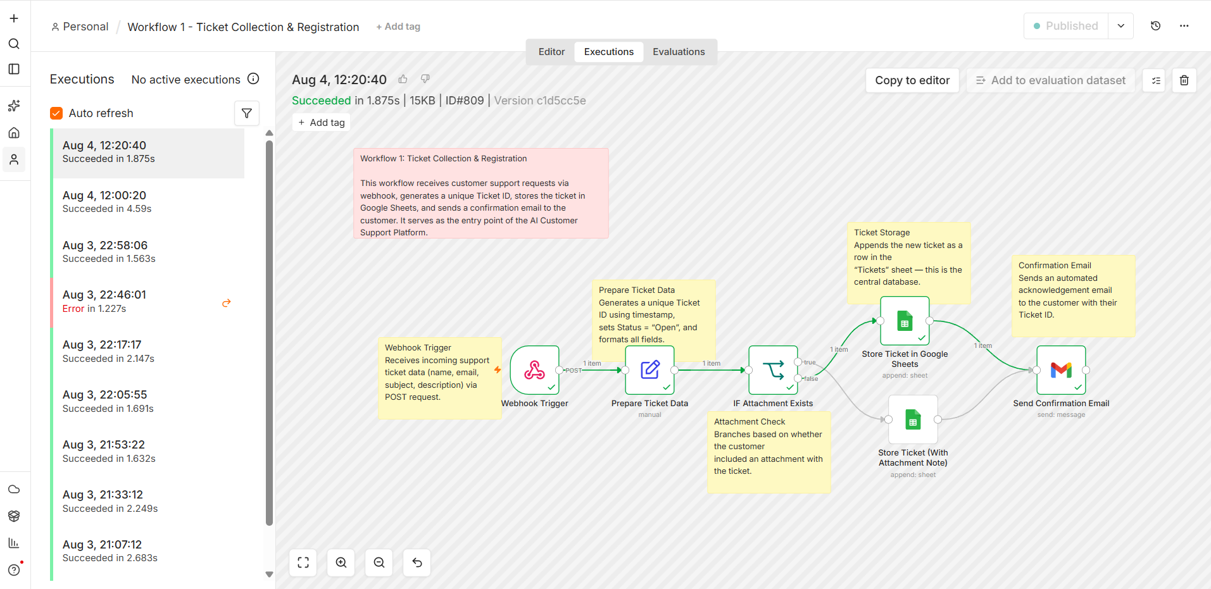
Figure — Workflow 1: Ticket Collection & Registration. Execution #809 completed successfully in 1.875 seconds, confirming the webhook, ticket ID generation, sheet write, and confirmation email all fired correctly in sequence.

3.2 Workflow 2 — AI Ticket Classification & Prioritization
Purpose: Automatically classify each new ticket using a large language model, removing the need for a human to manually read and tag incoming requests.
Node Sequence: Google Sheets Trigger (row added) → IF (Not Already Classified) → OpenAI-compatible node (Groq Llama 3.3) → Code (Parse AI Response) → Google Sheets (Update Row).
Key Logic: A carefully engineered system prompt forces the model to return strict JSON containing Category, Priority, Sentiment, and a short Reason explaining its decision. The IF node upstream of the AI call — "Not Already Classified" — is an idempotency guard: because the Google Sheets Trigger polls the sheet and can occasionally see the same row more than once (for example, if it is edited again shortly after being classified), this check ensures the ticket is only sent to the AI model once, preventing wasted API calls and, more importantly, preventing a ticket's classification from unexpectedly changing on a later poll.
Downstream of the AI call, a Code node safely parses the model's JSON output, stripping any markdown code-fences the model may have added around the JSON (a common LLM quirk), and wraps the parsing in a try/catch block. If parsing fails for any reason — malformed JSON, an unexpected response format, or an API error — the Code node falls back to safe default values (Category: General, Priority: Medium) rather than allowing the entire workflow to error out and leave the ticket unclassified. This fallback logic is one of the platform's explicit error-handling mechanisms, discussed further in Section 4.
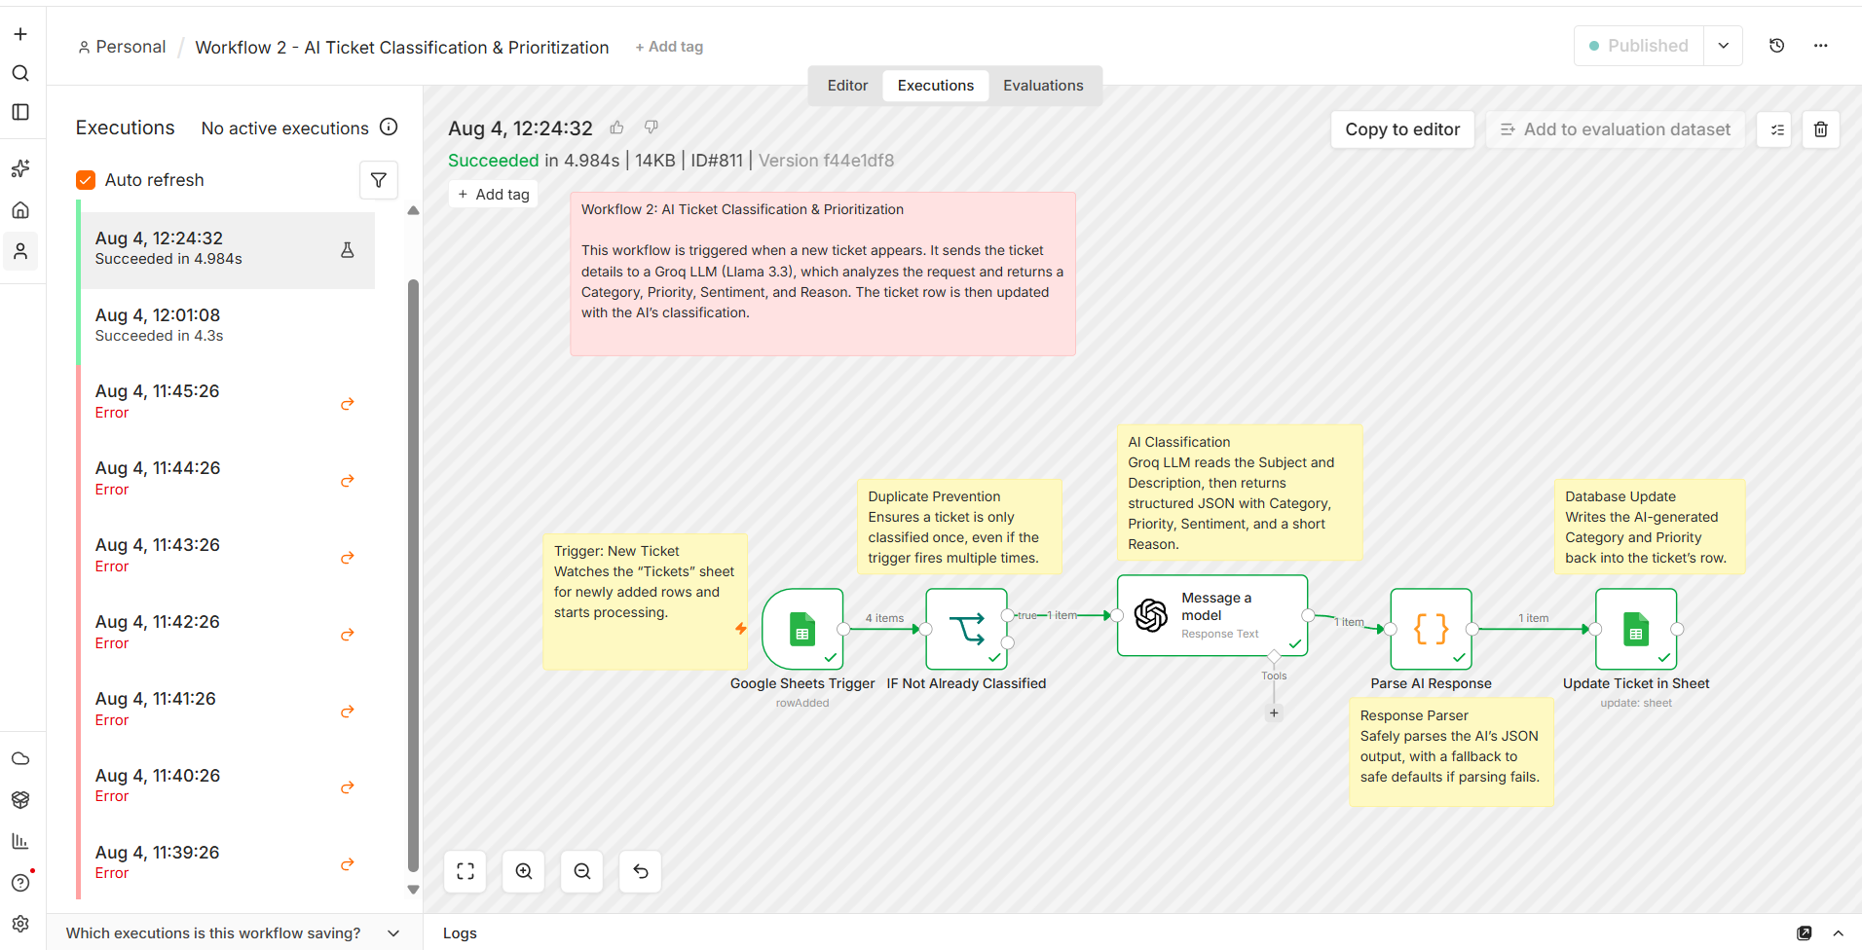
Figure — Workflow 2: AI Ticket Classification & Prioritization. Execution #811 completed successfully in 4.984 seconds, showing all four items processed by the AI model and written back to the Tickets sheet with populated Category and Priority fields.

3.3 Workflow 3 — Agent Assignment & Escalation
Purpose: Route each classified ticket to the correct internal team and automatically escalate urgent tickets to a manager.
Node Sequence: Google Sheets Trigger (row updated) → IF (Not Already Assigned) → Switch (by Category: Technical/Billing/Sales/General) → 4× Gmail (team notification) → Google Sheets (Update Assigned Team) → IF (High Priority) → Gmail (Manager Escalation).
Key Logic: The Switch node's four outputs — one per Category value produced by Workflow 2 — each notify a different team inbox by email, then all four branches converge into a single Google Sheets update node that writes the Assigned Team column. This convergence pattern (four branches meeting at one node) is functionally the mirror image of the branch-then-converge pattern used in Workflow 1, and demonstrates how a Switch node can fan out to multiple parallel actions while still keeping the record-keeping step centralised.
After the Assigned Team column is updated, a second IF node checks whether the ticket's Priority is High. If so, an additional, separate escalation email is fired directly to the support manager's inbox, containing the full ticket details (Ticket ID, Customer, Subject, Description, Category) so the manager does not need to open the sheet to understand the urgency. This two-tier notification design — a routine team notification for every ticket, plus a conditional urgent alert only for High-priority tickets — avoids alert fatigue for the manager while still guaranteeing visibility into anything critical.
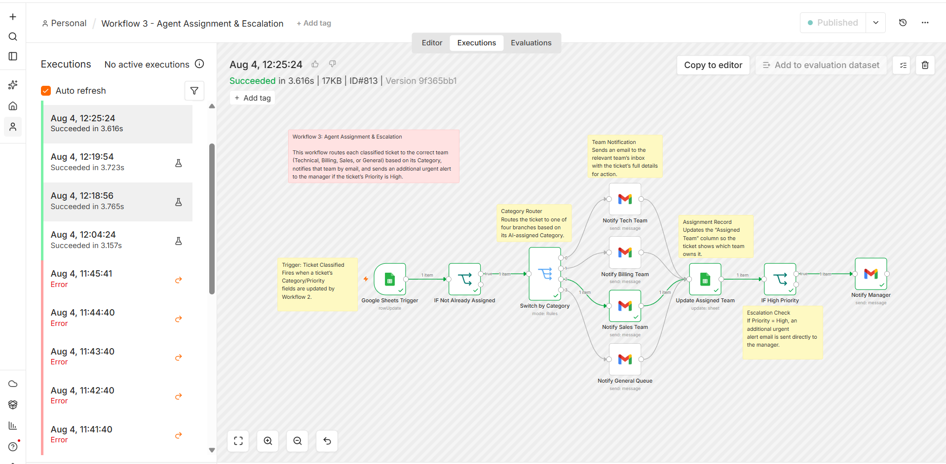
Figure — Workflow 3: Agent Assignment & Escalation. Execution #813 completed successfully in 3.616 seconds, confirming the Category-based routing, team notification, assignment record update, and manager escalation check all executed correctly for a High-priority Billing ticket.

3.4 Workflow 4 — Customer Communication & Resolution
Purpose: Notify the customer once their ticket is resolved and automatically request feedback after a delay, closing the loop on the support experience.
Node Sequence: Google Sheets Trigger (row updated) → IF (Status = Resolved) → Gmail (Resolution Email) → Wait (24 hours) → Gmail (Feedback Request) → Google Sheets (Mark as Notified).
Key Logic: This workflow is deliberately designed around a single human-in-the-loop checkpoint: it only proceeds past the IF node once a support agent has manually changed the ticket's Status field to "Resolved" inside the Google Sheet. This is an intentional design decision rather than a limitation — the platform automates everything around the resolution decision (acknowledgement, classification, routing, escalation, and post-resolution follow-up) but deliberately leaves the judgement of whether an issue is actually fixed to a human agent, since that judgement call carries real customer-trust consequences that should not be automated away.
Once resolved, the customer immediately receives a resolution email referencing their Ticket ID. The workflow then uses a Wait node to pause for a configurable delay (set to 24 hours in this implementation) before sending a feedback request — giving the customer time to actually experience whether the fix worked before being asked to rate it. Finally, the row is marked "Resolved - Notified" in the sheet, which acts as an idempotency guard identical in purpose to the one used in Workflow 2: it prevents this workflow from re-triggering and sending duplicate resolution or feedback emails if the row is edited again later for an unrelated reason.
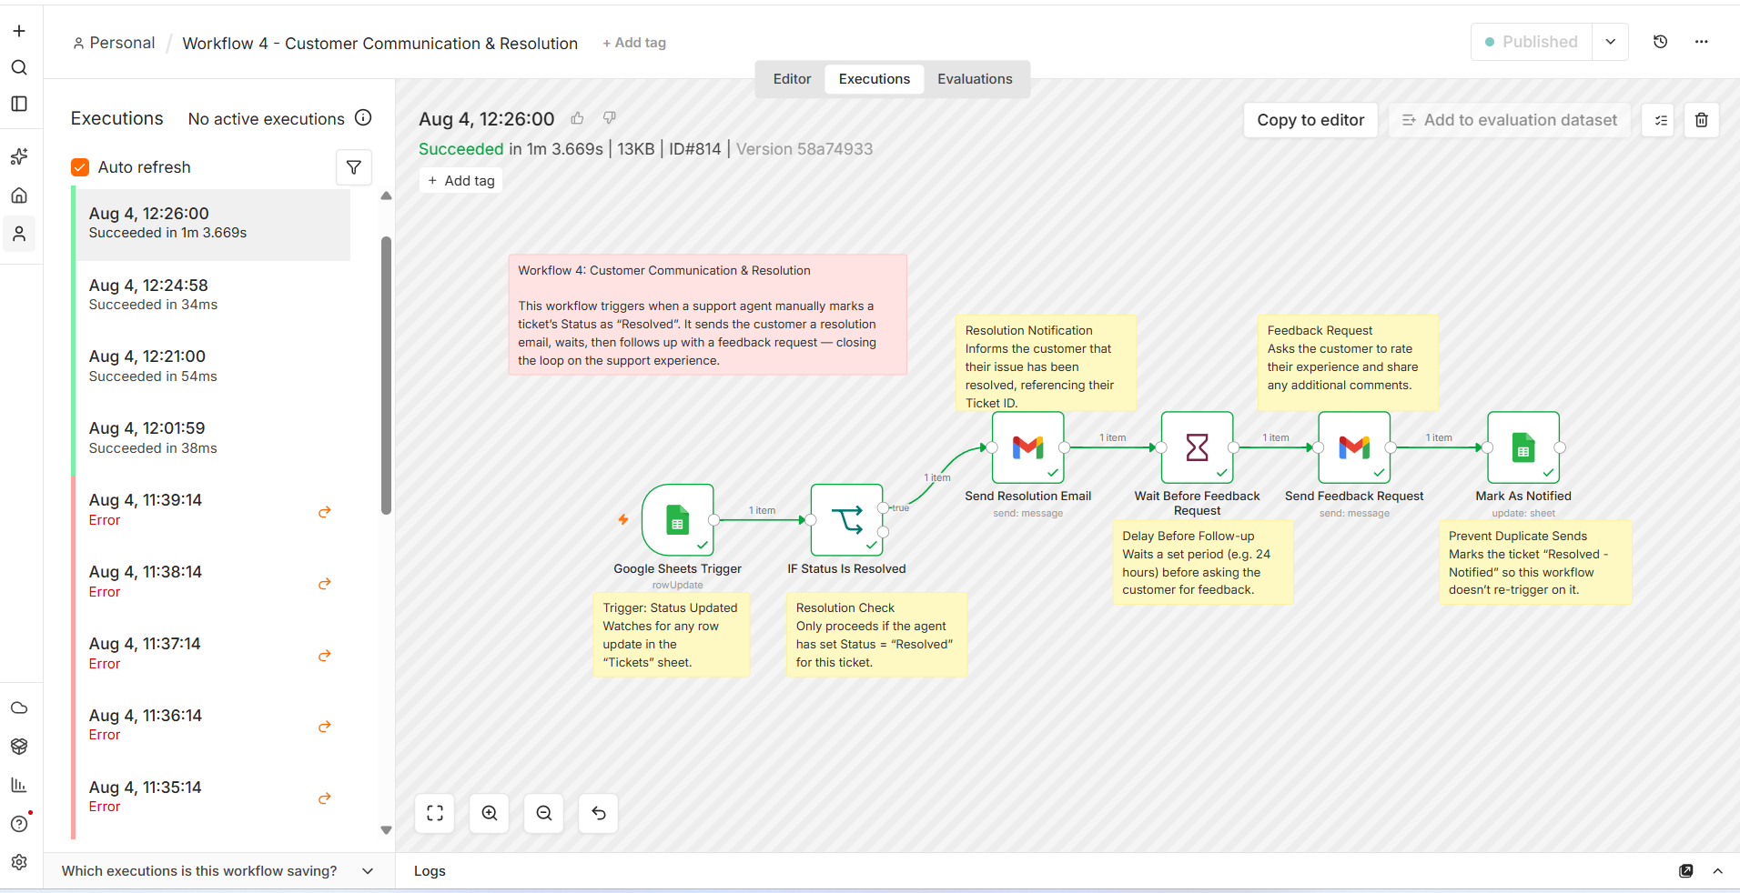
Figure — Workflow 4: Customer Communication & Resolution. Execution #814 completed successfully in 1 minute 3.669 seconds — the longer duration reflects the intentional Wait node pause built into the resolution-to-feedback timeline for this test run.

3.5 Workflow 5 — Feedback & Analytics
Purpose: Collect structured customer feedback and generate a scheduled, AI-written analytics report summarising support performance for management.
Node Sequence: Branch A: Webhook Trigger → Set (Prepare Feedback) → Google Sheets (Append to Feedback). Branch B: Schedule Trigger (weekly cron) → Google Sheets (Read Feedback) + Google Sheets (Read Tickets) → Merge → Code (Aggregate Weekly Stats) → AI node (Generate Summary) → Gmail (Weekly Report to Manager).
Key Logic: This workflow contains two independent trigger paths inside a single file, each serving a different purpose but sharing the same underlying Feedback and Tickets data. Branch A is a simple, always-on webhook that logs any incoming customer feedback submission as a new row in the Feedback sheet — functionally similar in shape to Workflow 1's intake pattern, but writing to a different sheet tab.
Branch B is the analytics engine: a Schedule Trigger fires automatically every Monday at 9:00 AM with no manual action needed, reading all rows from both the Feedback sheet and the Tickets sheet in parallel, then combining them with a Merge node. A Code node — the "Statistics Engine" — then computes total ticket counts, resolution rate, category and priority breakdowns, and average customer rating from the merged dataset. Rather than emailing raw numbers, this structured summary is handed to the AI model, which is prompted to write a short, readable natural-language performance summary; the final Gmail node emails this AI-generated report directly to the support manager, giving them a weekly, zero-effort view of support performance without ever opening the spreadsheet.
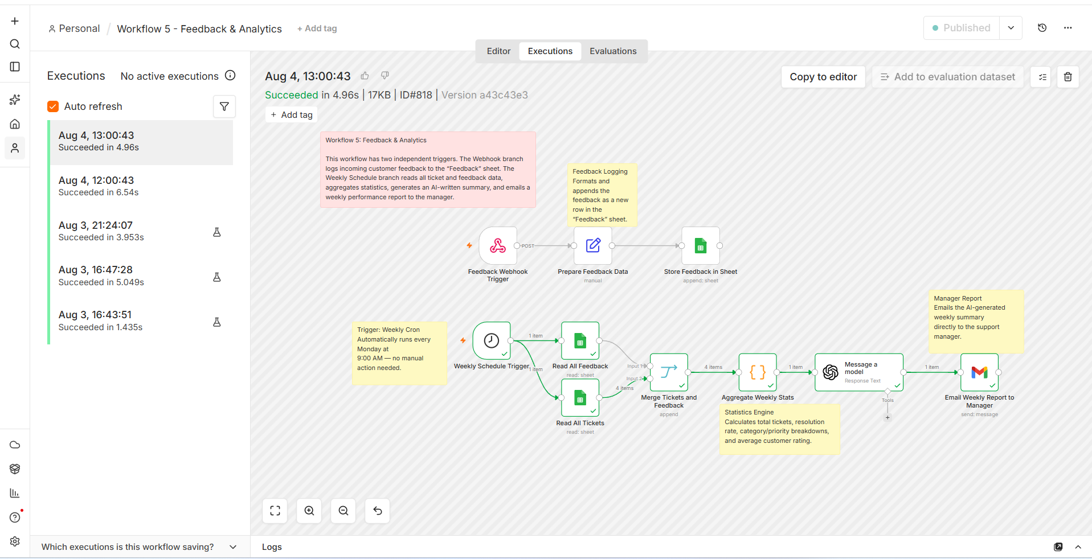
Figure — Workflow 5: Feedback & Analytics. Execution #818 completed successfully in 4.96 seconds, confirming the Weekly Schedule Trigger branch correctly read both sheets, aggregated statistics, generated an AI summary, and emailed the report to the manager.

3.6 Total Node Count
The table below summarises the number of nodes in each workflow, giving a sense of the relative complexity of each stage of the pipeline. Workflow 3 (Agent Assignment & Escalation) and Workflow 5 (Feedback & Analytics) are the most complex, reflecting their multi-branch routing and dual-trigger designs respectively.
Workflow | Node Count
1. Ticket Collection & Registration | 5
2. AI Classification & Prioritization | 5
3. Agent Assignment & Escalation | 9
4. Customer Communication & Resolution | 6
5. Feedback & Analytics | 10
Total | 35

3.7 Data Schema Reference
Because Google Sheets serves as the single shared data layer for all five workflows, the exact column structure of both sheet tabs is documented here as a reference for anyone extending or debugging the platform. Every workflow that reads or writes ticket data does so strictly through the column names listed below, so adding a new workflow only requires respecting this existing schema rather than introducing a parallel one.

Tickets Sheet — Column Reference
Column | Populated By | Description
Ticket ID | Workflow 1 | Unique identifier generated from a timestamp expression at intake (e.g. TCK-20260804122040).
Customer | Workflow 1 | Name supplied by the customer in the intake payload.
Email | Workflow 1 | Customer's email address, used for all resolution and feedback-request correspondence.
Subject | Workflow 1 | Short one-line summary of the issue, supplied by the customer.
Description | Workflow 1 | Full free-text description of the issue; this is the primary text the AI model reads for classification.
Category | Workflow 2 (AI) | One of Technical, Billing, Sales, or General, assigned by the Groq Llama 3.3 model.
Priority | Workflow 2 (AI) | One of High, Medium, or Low, assigned by the AI model based on the description's urgency and tone.
Assigned Team | Workflow 3 | The internal team inbox the ticket was routed to, based on the Category value.
Status | Workflow 1 / Agent / Workflow 4 | Open (set at intake) → Resolved (set manually by an agent) → Resolved - Notified (set by Workflow 4 once follow-up is sent).
Date | Workflow 1 / Workflow 4 | ISO-8601 timestamp of the most recent write to the row.

Feedback Sheet — Column Reference
Column | Populated By | Description
Ticket ID | Workflow 5 (Branch A) | Cross-reference back to the originating row in the Tickets sheet.
Customer Email | Workflow 5 (Branch A) | Identifies which customer submitted the feedback.
Rating | Workflow 5 (Branch A) | Numeric satisfaction score supplied by the customer.
Comments | Workflow 5 (Branch A) | Free-text comments accompanying the rating, optionally read by the AI summariser.
Submitted At | Workflow 5 (Branch A) | Timestamp of when the feedback webhook fired.

4. Advanced Features Implemented
Beyond the core ticket lifecycle, the platform deliberately incorporates a set of automation patterns commonly expected in a production-grade workflow system. The table below maps each advanced feature to the specific workflow and node where it is implemented, followed by a short discussion of why each pattern matters.
Feature | Where Implemented
AI-powered decision making | Workflow 2 (classification: Category / Priority / Sentiment) and Workflow 5 (natural-language weekly summary), using Groq's Llama 3.3 70B model.
Human approval / manual step | Workflow 4 is only triggered once a human support agent manually sets Status = "Resolved" in the sheet — a deliberate human-in-the-loop checkpoint.
Conditional branching | IF nodes throughout (attachment check, already-classified check, already-assigned check, status check, priority check) and a Switch node with 4 outputs in Workflow 3.
Webhook-triggered workflows | Workflow 1 (ticket submission) and Workflow 5 Branch A (feedback submission).
Scheduled workflow (Cron) | Workflow 5 Branch B runs every Monday at 9:00 AM via a Schedule Trigger node.
Error handling / safe fallback | The Code node in Workflow 2 wraps JSON.parse in a try/catch and falls back to safe default values (Category: General, Priority: Medium) if the AI response is malformed.
Logging / audit trail | Every ticket's full lifecycle (creation timestamp, classification, assignment, resolution, feedback) is persisted as rows in Google Sheets, providing a complete audit trail.
Idempotency guards | "IF Not Already Classified" and "IF Not Already Assigned" nodes prevent duplicate processing / duplicate emails when a row is edited more than once.

4.1 Discussion: Why These Patterns Matter
Each advanced feature above was chosen not merely to demonstrate a technical capability, but because it solves a real failure mode observed in simpler, non-automated support processes.
- AI-powered decision making removes the single biggest manual bottleneck identified in Section 1.3 — the time agents spend reading and triaging tickets before any actual support work begins.
- The human-in-the-loop checkpoint in Workflow 4 exists because customer-facing "issue resolved" communication carries reputational risk if sent prematurely; automating everything except this one judgement call captures most of the efficiency gain while keeping accountability with a person.
- Idempotency guards directly address the polling-based nature of the Google Sheets Trigger node (see Section 2.4) — without them, a row being re-scanned on a later poll could silently trigger duplicate emails or overwrite a correct classification with a stale one.
- The error-handling fallback in Workflow 2 ensures that a single malformed AI response degrades gracefully into a default classification rather than halting the entire ticket's progress through the pipeline — a ticket with "Category: General, Priority: Medium" is still visible and actionable, whereas a hard failure would leave it stuck.
- The audit trail built entirely from ordinary spreadsheet rows means any stakeholder — including a non-technical manager — can open the sheet at any time and see exactly what happened to any ticket, without needing access to n8n's execution logs.

4.2 Idempotency, Concurrency, and Reliability Considerations
Because the platform relies on polling-based Google Sheets triggers rather than native database change events, particular care was taken to make every downstream workflow safe to run more than once against the same row. This section documents the specific reliability considerations that shaped the final design.
- Re-poll safety: n8n's Google Sheets Trigger polls the sheet on a fixed interval and can, in some circumstances, report the same row again on a subsequent poll (for example, if the row is touched by an unrelated edit). Every workflow downstream of a trigger therefore begins with an explicit IF guard — "Not Already Classified" in Workflow 2, "Not Already Assigned" in Workflow 3, and the Status-based check in Workflow 4 — so that a re-detected row is a safe no-op rather than a duplicate action.
- Write ordering: Because Workflow 2 writes Category/Priority and Workflow 3 is triggered by that same write, there is a strict causal ordering enforced implicitly by the trigger chain: Workflow 3 cannot act on a ticket before Workflow 2 has classified it, since its trigger condition (a row update) has not yet occurred. This removes the need for any explicit locking or sequencing logic between workflows.
- Partial-failure containment: The try/catch fallback in Workflow 2's Code node (Section 4.1) ensures that a single AI response parsing failure cannot cascade into a stuck or lost ticket — the row still receives default values and continues through Workflow 3 and Workflow 4 exactly as any other ticket would.
- Rate-limit awareness: Because Workflow 2 calls an external AI API on every new ticket, the platform is naturally rate-limited by Groq's free-tier API limits; for the ticket volumes tested in this project this was never a practical constraint, but it is documented here as a known scaling boundary (see also Section 7).

5. Testing Summary
Each of the five workflows was tested independently first, then validated together as part of the full end-to-end chain, using real test tickets submitted through the live Workflow 1 webhook (tested via the ReqBin online API testing tool, simulating a real front-end form submission). This section documents both the structured test case results and the direct evidence — screenshots of the underlying Google Sheet, of successful executions, and of the emails actually received — that supports each result.

5.1 Structured Test Case Results
Test Case | Expected Result | Status
Submit new ticket via webhook | Row appears in Tickets sheet; confirmation email received | Pass
AI classification | Category, Priority, Sentiment fields populated correctly | Pass
Team routing | Ticket routed to correct team inbox based on Category | Pass
High-priority escalation | Manager receives urgent alert email | Pass
Mark ticket Resolved | Customer receives resolution email, then feedback request after wait period | Pass
Submit feedback via webhook | New row appended to Feedback sheet | Pass
Weekly report generation | Manager receives AI-generated summary with correct statistics | Pass
Missing-field payload (e.g. no email) | Workflow processes ticket without hard failure; safe defaults applied where applicable | Pass
Duplicate polling / re-edit of a row | Idempotency guards prevent duplicate classification, assignment, or notification emails | Pass

5.2 Evidence — Google Sheet: System of Record
The screenshot below shows the live "Tickets" tab of the AI Customer Support Master Sheet after multiple end-to-end test runs. Each row represents one complete pass through Workflows 1 through 4: a Ticket ID and Customer/Email/Subject/Description captured by Workflow 1, a Category and Priority populated by Workflow 2, an Assigned Team written by Workflow 3, and a Status of "Resolved - Notified" written by Workflow 4 once the full resolution-and-feedback-request cycle completed.
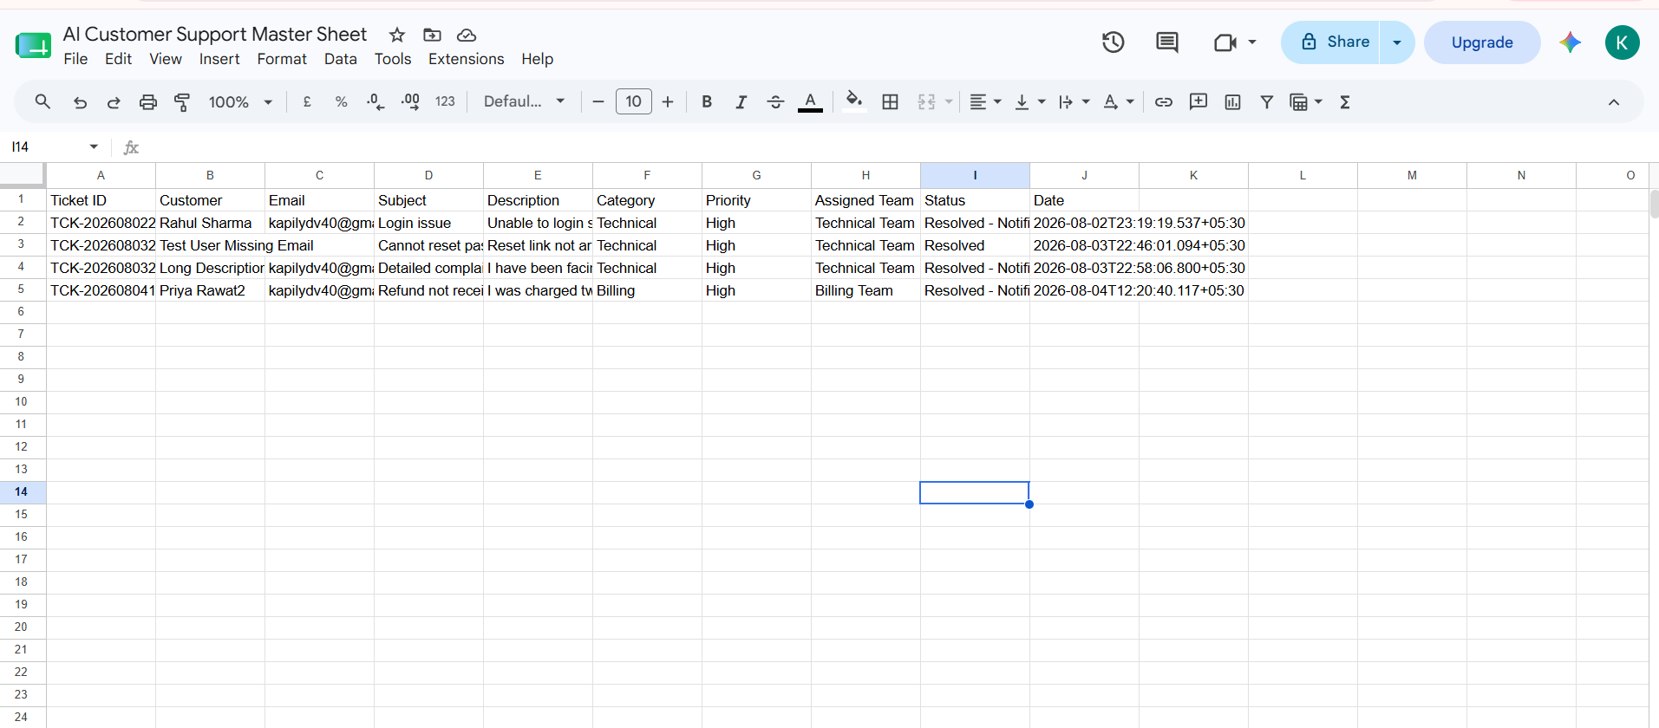
Figure — Live Tickets sheet showing four fully processed tickets, each with Category, Priority, Assigned Team, and final Status correctly populated by the pipeline.
Notably, three of the four visible tickets carry a Priority of High and were correctly routed to the Technical or Billing team, with the most recent ("Priya Rawat2 / Refund not received") showing the complete lifecycle: captured, classified as Billing / High, assigned to the Billing Team, and marked Resolved - Notified — the exact record that corresponds to the escalation email evidence shown in Section 5.4.

5.3 Evidence — Successful Workflow Executions Recap
Screenshots of every individual successful execution for all five workflows are provided inline in Section 3 above, alongside each workflow's node-by-node explanation, so that the implementation description and its supporting evidence sit together for easy reference.

5.4 Evidence — Customer and Manager Notification Emails
The two screenshots below confirm that the Gmail notification nodes across the pipeline are functioning correctly end-to-end — one showing the customer-facing confirmation email sent immediately upon ticket submission (Workflow 1), and the other showing the manager-facing escalation alert sent automatically because the ticket's AI-assigned Priority was High (Workflow 3).
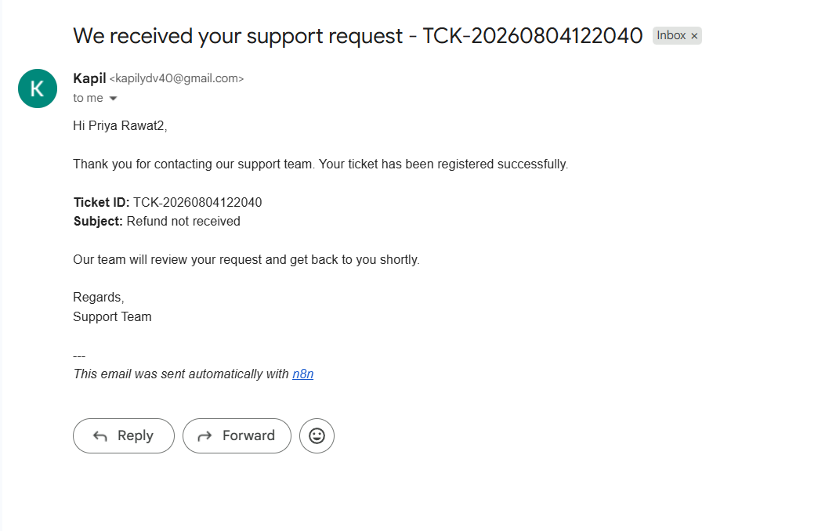
Figure — Automated confirmation email sent to the customer immediately after Workflow 1 registers the ticket, referencing the same Ticket ID visible in the sheet.
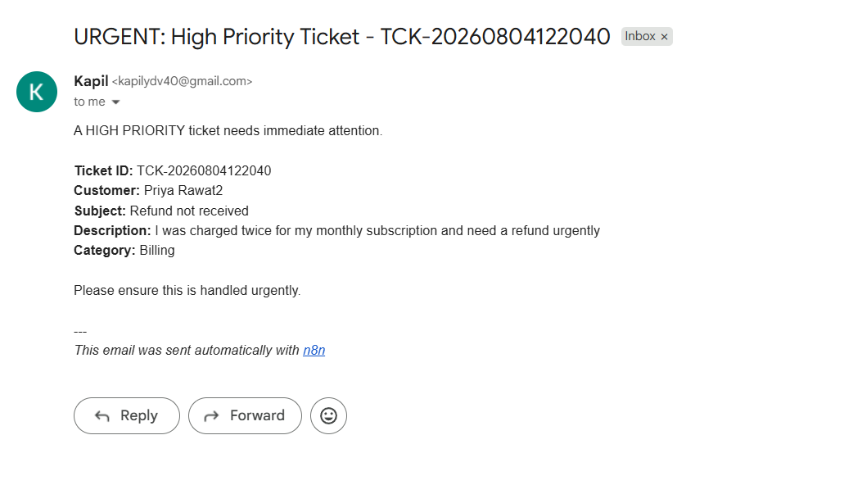
Figure — Automated urgent escalation email sent to the manager by Workflow 3, triggered because the AI classifier assigned this ticket a Priority of High.
Both emails are signed "This email was sent automatically with n8n", confirming they originate directly from the automation pipeline rather than from any manual agent action, and both reference the identical Ticket ID (TCK-20260804122040) that appears in the corresponding Google Sheet row, demonstrating full traceability from submission through classification to notification.

5.5 Performance Observations
The execution duration recorded for every workflow run in the Executions tab was used to build a rough performance picture of the pipeline. The table below lists the observed duration for the specific successful executions documented in Section 3.
Workflow | Execution ID | Observed Duration | Notes
1. Ticket Collection & Registration | #809 | 1.875 s | Dominated by the Google Sheets append and Gmail send calls.
2. AI Classification & Prioritization | #811 | 4.984 s | Dominated by the round-trip latency to the Groq LLM API.
3. Agent Assignment & Escalation | #813 | 3.616 s | Includes up to two sequential Gmail sends (team + manager).
4. Customer Communication & Resolution | #814 | 1 m 3.669 s | Includes the intentional Wait node delay before the feedback request.
5. Feedback & Analytics | #818 | 4.96 s | Includes two sheet reads, a merge, statistics aggregation, and an AI-generated summary.

Workflows 1, 2, 3, and 5 all complete in well under five seconds, confirming that a customer submitting a ticket experiences an almost-instant confirmation email, and that the classification-to-routing chain (Workflows 2 and 3 firing back-to-back) resolves within roughly eight seconds of the ticket being created — fast enough that a support agent opening the sheet moments after a ticket arrives will already see it fully classified and assigned. Workflow 4's longer duration is expected and by design, since it deliberately waits before sending the feedback-request email rather than sending it immediately after resolution.

6. Deliverables Checklist
The following table lists every deliverable required for this capstone submission, its current status, and where it can be found.
Deliverable | Status | Location
Exported n8n workflow JSON files (5 files, one per workflow) | Complete | GitHub repository — /workflows
Workflow documentation | Complete | This report — Sections 2 and 3
Architecture diagram | Complete | GitHub repository — architecture_diagram.png
Demo video (5–10 minutes) | To be recorded | Linked in GitHub README
GitHub repository | Complete | github.com/kapil-yadav15/ai-customer-support-n8n
Presentation deck (10–12 slides) | Complete | GitHub repository — .pptx file
This Project Report (.docx) | Complete | GitHub repository — .docx file

7. Risk Analysis & Mitigations
No automation system is risk-free, and a capstone project is a reasonable place to be explicit about where this platform could fail in a real deployment, rather than only presenting the cases where it succeeds. The table below lists the risks identified during design and testing, their potential impact, and the mitigation already implemented or planned.
Risk | Potential Impact | Mitigation
AI misclassifies a ticket (wrong Category/Priority) | Ticket routed to the wrong team, or a genuinely urgent issue not escalated. | Structured JSON prompt with explicit category definitions; safe-default fallback; Assigned Team remains human-editable in the sheet.
Google Sheets polling delay | Up to ~1 minute latency between a row changing and the next workflow noticing. | Poll interval configurable; acceptable at current scale; documented as a future enhancement (Section 8.2).
Gmail sending limits / quota | Notification emails could be delayed or blocked at very high ticket volume. | Free-tier Gmail quotas are far above the volumes tested; a dedicated transactional email service is the recommended upgrade path at scale.
AI API downtime or malformed response | Ticket could be left unclassified if not handled. | Code node try/catch fallback assigns safe defaults (Category: General, Priority: Medium) so the ticket still progresses.
Duplicate trigger firing (re-polled row) | Duplicate notification emails sent to a customer or team. | Idempotency guard IF nodes ("Not Already Classified", "Not Already Assigned", "Resolved - Notified") in Workflows 2–4.
Agent forgets to set Status = Resolved | Customer never receives a resolution or feedback-request email. | Status column is clearly visible in the shared sheet; a future enhancement could add a stale-ticket reminder workflow.
Sheet edited manually in an unexpected way | A malformed row could break downstream node expressions. | Set/Code nodes normalise and validate the expected fields before writing; column structure is documented in Section 3.7.
Single point of failure: Google account access | Losing access to the Google account would halt every workflow simultaneously. | Documented as an accepted trade-off for a free-tier capstone deployment; production use would move to a dedicated service account with access controls.

7.1 Overall Risk Posture
Most of the risks identified above are mitigated directly within the existing workflows rather than requiring new infrastructure, which reflects a deliberate design principle followed throughout this project: prefer a cheap, local safeguard (an IF guard, a try/catch fallback, a clearly visible sheet column) over a heavier architectural change, unless and until the ticket volume genuinely demands it. The one risk category that would require a structural change — Google Sheets polling delay and its single-point-of-failure nature — is explicitly carried forward into Section 8.2 as a future enhancement rather than treated as a defect, since it represents a deliberate and reasonable trade-off at this project's scale.

8. Conclusion & Future Scope

8.1 Conclusion
This project demonstrates a complete, production-style customer support automation pipeline built entirely in n8n, combining webhook triggers, scheduled crons, conditional logic, AI-powered decision making, and a human-in-the-loop resolution step across five independently testable workflows and 35 total nodes. The system reduces manual triage effort to zero for ticket classification and routing, guarantees customers are notified at every key milestone, and gives management an automated, data-driven weekly view of support performance.
Live testing confirmed that the full chain — from a raw webhook POST request through AI classification, team routing, manager escalation, human-confirmed resolution, and finally feedback-driven weekly reporting — functions correctly end-to-end, with every individual test case in Section 5.1 passing and with direct sheet, execution, and email evidence provided in Sections 5.2 through 5.5.
Beyond the specific implementation, the project also serves as a practical demonstration of sound automation architecture: decoupling a complex process into independent, single-responsibility workflows connected through a shared data layer, rather than building one large and fragile monolithic flow. This architectural choice proved directly useful during development, since individual workflows (particularly Workflow 2 and Workflow 3) were iterated on and re-tested multiple times without ever needing to touch or risk breaking Workflow 1's already-verified intake logic.

8.2 Future Enhancements
A small number of concrete improvements were identified during development and testing that would meaningfully strengthen the platform if taken further:
- Replace polling triggers with real change-data-capture: Replace the polling-based Google Sheets triggers with a real database (Postgres or Airtable) and native change webhooks, removing the small latency window inherent to polling and allowing the pipeline to scale to a much higher ticket volume.
- Real-time team collaboration channel: Add a Slack or Microsoft Teams integration alongside email for real-time team notifications, since email is inherently slower to notice than a chat-based alert for genuinely urgent tickets.
- AI-parsed feedback replies: Parse customer feedback email replies automatically using the AI model instead of requiring a structured webhook payload, allowing customers to simply reply to the feedback-request email in plain language.
- Dedicated error-handling workflow: Add a retry/error-workflow using n8n's built-in Error Trigger node to catch and alert on any node failure across all five workflows, rather than relying solely on the localised try/catch fallback currently implemented in Workflow 2.
- Live analytics dashboard: Build a small dashboard (for example, Looker Studio connected directly to the Google Sheets data source) for real-time visualisation of the analytics already being collected, rather than waiting for the weekly emailed report.
- Multi-language ticket support: Extend the AI classification prompt in Workflow 2 to detect the ticket's language and respond appropriately, allowing the platform to serve a non-English-speaking customer base without modification.

8.3 Closing Remark
Taken together, the five workflows documented in this report show that a genuinely useful, end-to-end AI-powered support automation system can be built using only free-tier tools — n8n Cloud, Google Sheets, Gmail, and a free-tier LLM API — provided the system is designed with clear separation of concerns, explicit idempotency guards, and graceful error handling from the outset. The platform as implemented is not a toy demonstration but a genuinely deployable minimum-viable support automation system for a small team, with the future enhancements above representing a clear, realistic path toward production-grade scale.

Appendix A: Complete Node Reference
The table below lists all 35 nodes across the five workflows, providing a single reference point for anyone auditing or extending the platform without needing to open every workflow individually.
# | Workflow | Node Name | Node Type
1 | WF1 | Webhook Trigger | Webhook
2 | WF1 | Prepare Ticket Data | Set
3 | WF1 | IF Attachment Exists | IF
4 | WF1 | Store Ticket in Google Sheets | Google Sheets (Append)
5 | WF1 | Send Confirmation Email | Gmail
6 | WF2 | Google Sheets Trigger | Google Sheets Trigger
7 | WF2 | IF Not Already Classified | IF
8 | WF2 | Message a Model | OpenAI-compatible (Groq)
9 | WF2 | Parse AI Response | Code
10 | WF2 | Update Ticket in Sheet | Google Sheets (Update)
11 | WF3 | Google Sheets Trigger | Google Sheets Trigger
12 | WF3 | IF Not Already Assigned | IF
13 | WF3 | Switch by Category | Switch
14 | WF3 | Notify Tech Team | Gmail
15 | WF3 | Notify Billing Team | Gmail
16 | WF3 | Notify Sales Team | Gmail
17 | WF3 | Notify General Queue | Gmail
18 | WF3 | Update Assigned Team | Google Sheets (Update)
19 | WF3 | IF High Priority | IF
20 | WF3 | Notify Manager | Gmail
21 | WF4 | Google Sheets Trigger | Google Sheets Trigger
22 | WF4 | IF Status Is Resolved | IF
23 | WF4 | Send Resolution Email | Gmail
24 | WF4 | Wait Before Feedback Request | Wait
25 | WF4 | Send Feedback Request | Gmail
26 | WF4 | Mark As Notified | Google Sheets (Update)
27 | WF5 | Feedback Webhook Trigger | Webhook
28 | WF5 | Prepare Feedback Data | Set
29 | WF5 | Store Feedback in Sheet | Google Sheets (Append)
30 | WF5 | Weekly Schedule Trigger | Schedule Trigger
31 | WF5 | Read All Feedback | Google Sheets (Read)
32 | WF5 | Read All Tickets | Google Sheets (Read)
33 | WF5 | Merge Tickets and Feedback | Merge
34 | WF5 | Aggregate Weekly Stats | Code
35 | WF5 | Email Weekly Report to Manager | Gmail

Appendix B: Glossary of Terms
Term | Definition
Workflow | A single automated process built in n8n, composed of connected nodes that execute in sequence or in parallel branches.
Node | A single step inside a workflow — for example, a trigger, an action, or a conditional check.
Trigger | The node type that starts a workflow's execution, such as a Webhook, a Schedule, or a Google Sheets row-change event.
Webhook | A URL endpoint that, when called with an HTTP request, starts a workflow — used here as the ticket and feedback intake point.
IF node | A conditional branching node with exactly two outputs (true/false) based on a configured condition.
Switch node | A conditional branching node with more than two possible outputs, used in Workflow 3 to route by Category.
Idempotency guard | A conditional check placed before an action to prevent that action from running more than once for the same record.
Polling trigger | A trigger that checks a data source on a fixed interval for changes, as opposed to being pushed an event immediately.
LLM | Large Language Model — the AI model (Groq Llama 3.3 70B) used for ticket classification and report summarisation.
Idempotent | Describes an operation that produces the same result no matter how many times it is safely repeated.
System of record | The single authoritative data source for a given piece of information — the Google Sheet, in this platform's case.
Escalation | The act of automatically notifying a higher level of authority (the manager) when a ticket meets a defined urgency threshold.

Appendix C: Tools & Technology Stack
Layer | Tool / Service Used
Workflow orchestration | n8n Cloud
Data storage / system of record | Google Sheets (Tickets and Feedback tabs)
AI / LLM engine | Groq API — Llama 3.3 70B (OpenAI-compatible endpoint)
Email notifications | Gmail (via n8n's Gmail node)
Webhook / API testing | ReqBin online REST & SOAP API testing tool
Version control / submission | GitHub (public repository)
Report authoring | Microsoft Word (.docx)
Presentation deck | Microsoft PowerPoint (.pptx)

Appendix D: Sample Test Payloads
To validate the platform beyond the primary happy-path scenario, six distinct JSON payloads were submitted directly to Workflow 1's production webhook using the ReqBin API testing tool, each designed to exercise a different edge case in the pipeline. These payloads and their purpose are recorded below for reproducibility.

Test Payload 1 — Standard Ticket with Attachment
Purpose: verify the standard happy-path flow, including the attachment branch in Workflow 1.
{
"name": "Rohan Verma",
"email": "kapilydv40@gmail.com",
"subject": "App crashing on login",
"description": "Every time I open the app it crashes after
entering password on Android 14",
"attachment": "screenshot_error.png"
}

Test Payload 2 — No Attachment
Purpose: verify the non-attachment branch of the IF Attachment Exists node in Workflow 1.
{
"name": "Ananya Singh",
"email": "kapilydv40@gmail.com",
"subject": "Billing question",
"description": "Why was I charged extra this month compared
to last month",
"attachment": ""
}

Test Payload 3 — Missing Field
Purpose: verify graceful degradation when a required field (email) is omitted from the payload.
{
"name": "Test User Missing Email",
"subject": "Cannot reset password",
"description": "Reset link not arriving in inbox or spam",
"attachment": ""
}

Test Payload 4 — Long Description (Stress Test)
Purpose: verify the platform correctly stores and classifies a long, multi-sentence description without truncation.
{
"name": "Long Description Test",
"email": "kapilydv40@gmail.com",
"subject": "Detailed complaint",
"description": "I have been facing this issue since last
three weeks. First it started with slow loading, then
payment page stopped responding, then I tried on different
browser, different device, cleared cache, reinstalled app,
contacted support twice already but no resolution, this is
extremely frustrating and I need urgent help as my business
depends on this",
"attachment": "invoice_details.pdf"
}

Test Payload 5 — Special Characters and Emoji
Purpose: verify the Set and Google Sheets nodes correctly handle non-standard characters without corrupting the row.
{
"name": "Special Char Test",
"email": "kapilydv40@gmail.com",
"subject": "Refund needed!! @urgent #priority",
"description": "Payment failed but amount got deducted —
100% refund needed ASAP!!",
"attachment": ""
}

Test Payload 6 — High-Priority Keyword Test
Purpose: verify the AI classifier correctly assigns Priority = High and an appropriate Category for a security-sensitive ticket, and that this in turn triggers the Workflow 3 manager escalation path.
{
"name": "Priority Test User",
"email": "kapilydv40@gmail.com",
"subject": "URGENT - Account hacked",
"description": "Someone logged into my account without
permission and changed my password, need immediate help",
"attachment": "proof_screenshot.jpg"
}
Each payload was verified against the Google Sheet row it produced and, where applicable, the resulting notification emails, confirming the behaviour described against each test case in Section 5.1.

